GOVERNMENT ARTS AND SCIENCE COLLEGE CALICUT PAIN AND PALLIATIVE CARE UNIT

ACTIVITY REPORT FOR THE YEAR -2022-23

Teacher co ordinator : Dr SHANIBA V, Assistant Professor, Dept of Chemistry

Students’ coordinator: Rishikesh -II BSc chemistry

Agna - II BSc Mathematics

1. **Orientation programme**

Orientation program for the volunteers of Pain and Palliative care unit of Govt,arts and science college, Calicut conducted on 19.8.2022,2.30 PM at seminar hall in Collaboration with DAYA Palliative centre ,Areekad,Kozhikode.Principal Dr.Edakkott Shaji inaugurated the function and the program presided by Mr.Adam ,General secretary of DAYA. Dr. Muneer CP:Introduces the new coordinator Dr.Shaniba.V and welcome speech done by new coordinator. Talks conducted by Mr.Yoonus CP , Teacher and trainer of Velimukku Palliative unit on the topic Awarness of Pain and palliative unit. Anoof Paravannur, Assistant Professor,MES college,Trainer and counciller of Malappuram palliative unit Interacted with students by sharing his experiences in the Malappuram unit. Hamza , Student coordinator of Malappuram unit, talks on his experiences in the students wing of Malappuram unit.Delivered talks by Thahira,Binu and Habeeba Noushad ,volunteers of DAYA.

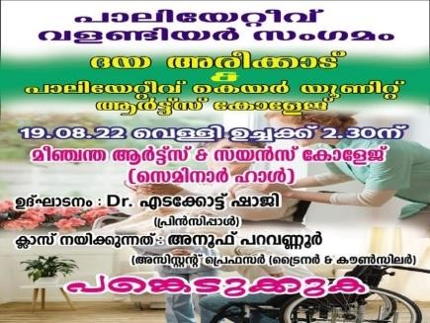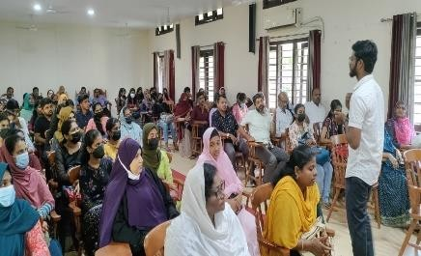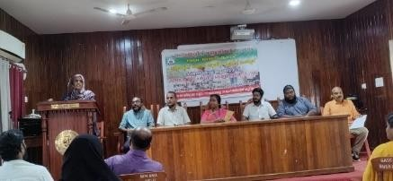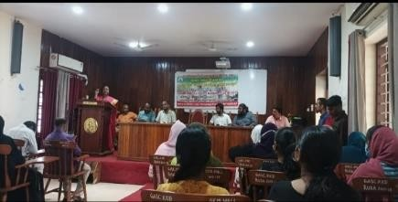

1. **ONAM Celebration with IQRAA -THANAL Pain and palliative unit Kozhikode**

Our 12 students participated as volunteers in the Onam celebration conducted for the Patients of IQRAA -THANAL on 3.9.2022 at Eranjippalam.

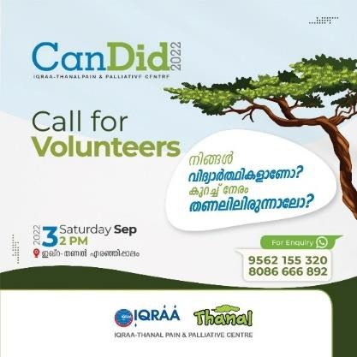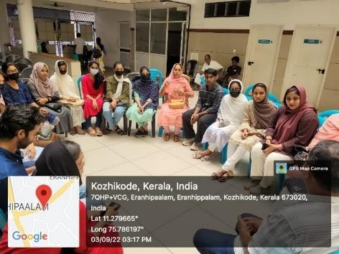

## World pain and Palliative Day 2022 as “Healing Hearts and Communities

Fund collected by our volunteers from the students, teaching and nonteaching staffs in related to word pain and palliative day on October 7 from 11.30pm to 12.30 pm. Fund collection inaugurated by Principal incharge, Mr.Ravi ,Associate Professor and HOD of Malayalam Department. Poster

related to theme of World pain and Palliative Day 2022 as “Healing Hearts and Communities” are

sticked in the notice board of various blocks in the college

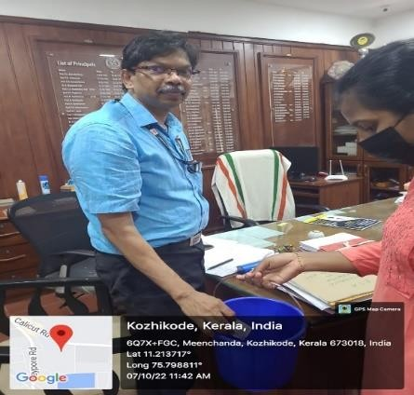

# Wold Mental Health day

World mental health day organized in the campus on collaboration with IQRAA -THANAL on 10.10 2022. The Vice principal and HOD of Hindi Department Dr.Mini E , Dr.Muneer CP,HOD of Chemistry department and Pre coordinator of pain and palliative care unit of college and Dr Shaniba V,co Ordinator of pain and palliative care unit of college gave awareness about the importance of campaigning about antidrug in the college campus in the present scenario.Campaigning against antidrugs done in the campus by Poster presentation in collaboration with students wing of IQRAA - THANAL . Our 13 volunteers also participated in the Ramanattukara and distributed awareness notice against antidrugs.

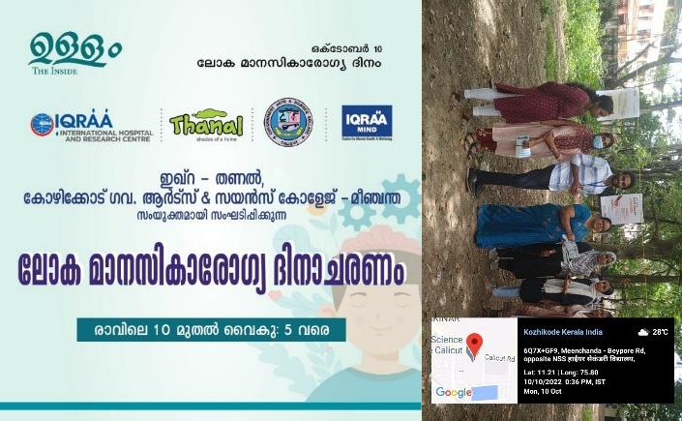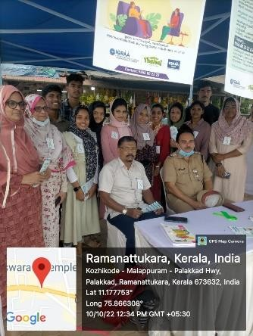

# Oldage home visit

32 students with coordinator visited to old age home Snehatheeram, at Kodambuzha, Farook college on 20.10.2022. Mr.Sidheek ,President of snehatheeram, addressed the students and give awareness about the importance of caring of parents and the activities of old age home.

Cake cutting, Cultural programs conducted by students with inmates and some amounts collected from our campus on world palliative day donated to them.

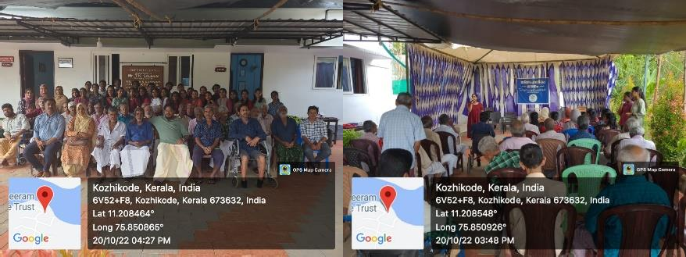

## Beach visit of patients of palliative care unit-Thanal-Iqraah

Our 15 volunteers participated and supported the patients for their gathering at Calicut beach on 24.11.2022 at evening from 4pm to 6pm.

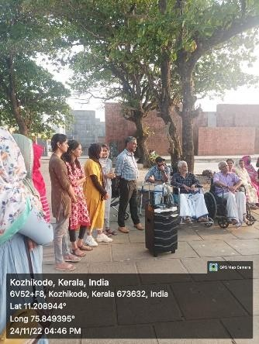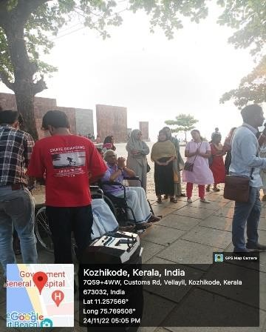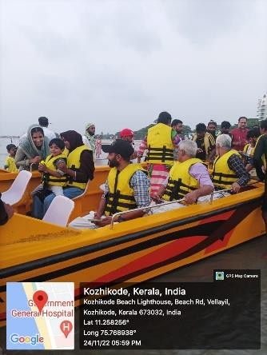

## Selection of new student coordinators from first year

Meeting of all first-year volunteers conducted at SG-17 at 1PM and selected coordinators from each department on 25.11.2022. Student coordinator delivered brief introduction about the activities of Pain and palliative unit of our college. Selected 20 volunteers from first year to participate in the Orientation program on 4.12.2022 conducted by DAYA pain and palliative unit Areekad

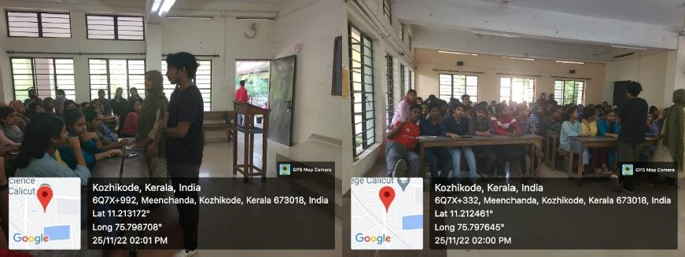

## Orientation programme

Orientation programm for first year volunteers conducted by DAYA palliative unit Areekad on 4.12.2022 at NOORJAS house ,Areekad.20 volunteers participated. Majeed sir,chairman of KIP Kozhikode took a effective class on Palliative care.

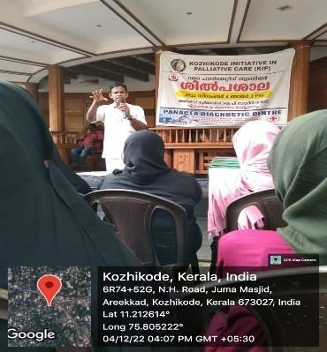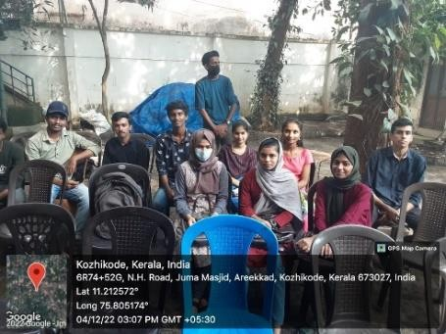

## Family get together of community palliative care society, Malaparamba at sarovaram Biopark

Family get together of community palliative care society, Malaparamba at sarovaram Biopark conducted on 10.1.2023 by Community palliative care society Malaparamba, Chevayur.22 students of our unit participated as volunteers. They also participated in the cultural programmes conducted for the patients. The coordinator appreciate our students for their wholehearted activities.

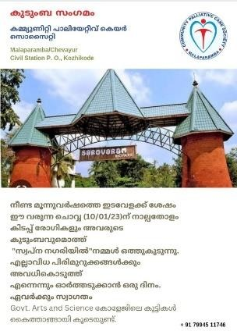

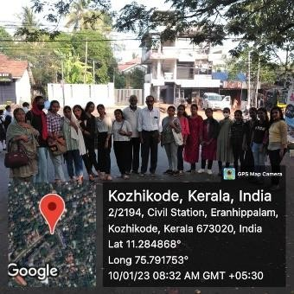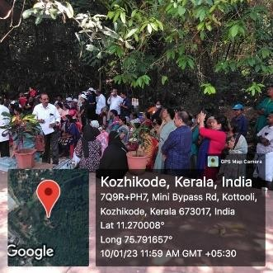

## Fund collection for community palliative care society at Beach flower show on 29.1.2023.

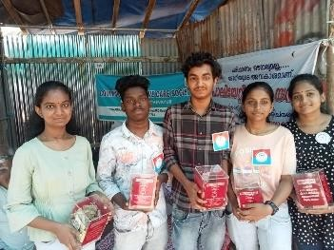

1. **Fund collection at college campus on 31.1.2023 in relation to Palliative care day on 15.1.2023**

## Training programe at IPM Kozhikode

Orientation program for First year Pain and palliative care unit conducted at IPM Kozhikode on1.2.2023. Mr.Saif Mohammed took class on palliative care and its importance in our society

Students involved in the activities for arranging Curios Carnival conductedin IPM Kozhikode on 17,18 and 19th February 2023.

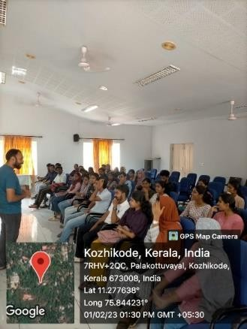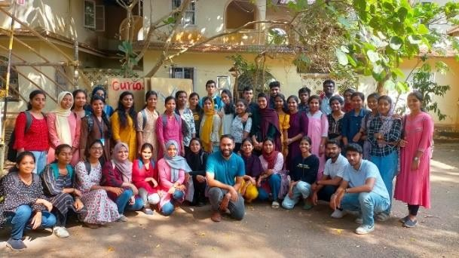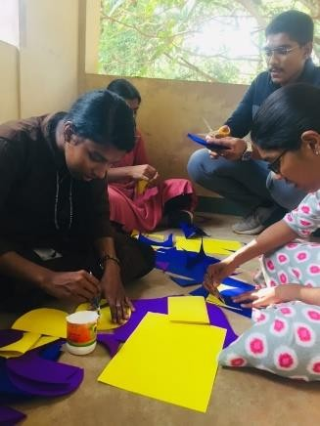

## Pain and Palliative care unit stall arranged in the Biodiversity congress conducted at Govt.Arts and science college Calicut-on 18,19and 20th February.

The aim and activities of palliative care unit conveyed to local peoples through stall arranged in the biodiversity congress. The products of Kerala Bilnd federation unit Cheruvannursold in the stall and the amount transferred to Kerala blind federation. Part of Funds collected from the campus and from the stall hand over to Daya Palliative unit Areekad.

